CYPRUS
Cyprus, an island of legends that basks year-round in the light of the warm Mediterranean sun. A storied past 10,000 years long has seen civilizations come and go and the likes of everyone from Alexander the Great to Cleopatra stake their claim here - but then, people do tend to get possessive when faced with such beauty. Aphrodite made her home on Cyprus, and travellers throughout antiquity came here just to pay her tribute.
Today Cyprus is a modern country that effortlessly marries European culture with ancient enchantment. Here you will discover a compact world of alluring beaches and fragrant mountain peaks, vineyards studded with olive trees and ancient ruins that stir the imagination, citrus groves and old stone villages where sweet wine flows as freely as conversations at the local café. A carefree place where a sense of timelessness is magnified by the kindness of the people.
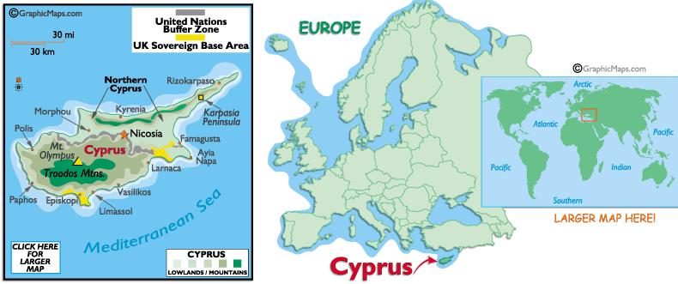
Accept the island's invitation, and you will find some 10,000 years of history to explore, Roman ruins with sea views, Byzantine churches tucked away in mountain valleys, sturdy Crusader castles, and villages where wine- and lace-making traditions still thrive. There is also no shortage of sun and sand, making Cyprus a hotspot for water sports enthusiasts and sun-seekers.
The island's vegetation is typically Mediterranean: this is a land of olive groves and citrus orchards, bright pink bougainvillea and spiny shrub thickets. In the Troodos Mountains, pine and cedar line the slopes, which often receive snow from late December through early April.
Humans are not the only travellers welcomed by the island: it lies on the north-south bird migration routes, bringing new colour to the island's resident bird populations in the form of some 150 million birds en route to their summer or winter homes (peak migration is usually March). February, March and April are the best months for the island's show of spring wildflowers such as anemones, tulips and orchids, with several species found only on Cyprus.
Thousands of tourists each year now come to sample the island's charms, putting it among Europe's favourite holiday destinations. Many come to enjoy the vibrant nightlife and young scene of Aiya Napa, but an increasing number are pleasantly surprised by the wealth of other attractions on offer here.
VISA: The visa is to be obtained prior to arrival in the country.

CLIMATE:
Cyprus enjoys an intense Mediterranean climate, with long dry summers from mid-May to mid-October and with mild winters from December to February, which are separated by short autumn and spring seasons. Summer is a season of high temperatures with cloudless skies, but the sea breeze creates a pleasant atmosphere in the coastal areas. Winters are mild with some rain and snow on Troodos Mountains (usually starting before Christmas). In Cyprus there is abundant sunshine as indicated in the tables above. Even in December and January, there is an average of six hours of bright sunshine per day

TIME:
Cyprus is 3 hrs 30 mins behind the Indian Standard Time.
ELECTRICITY:
The supply in Cyprus is 240 volts, a.c. 50Hz. Sockets are usually 13 amp, square-pin in most buildings. Adaptors can be purchased from electricians, supermarkets, grocery shops etc.

CLOTHES:
April – May: Medium-weight and summer apparel: Light woollies or long sleeved cotton for the evenings.
June–July–August: Very light weight summer clothing. Ideal for swimming and all beach/water activities
September – October: Lightweight apparel for the day and medium-weight for the evenings in October. Swimming and water-sports are still at their best.
December – January – February: Winter clothing; not heavy coats though!
March: Winter apparel with medium-weight wear.

CURRENCY:
The currency of the Republic is the Cyprus pound - CY£, which is divided into 100 cents.Notes and coins currently in circulation are as follows:
Banknotes: CY£20, CY£10, CY£5, CY£1.
Coins: 1 cent, 2 cents, 5 cents, 10 cents, 20 cents, 50 cents.
GETTING THERE:
Travellers arriving in the Republic of Cyprus may enter the Republic only through the legal ports of entry: Larnaka and Pafos International Airports, or the ports of Larnaka, Lemesos (Limassol), and Pafos.
By Air: There is no direct flight from India but there are daily flight connections from cities Dubai
( Emirates) and other Gulf countries ( Gulf Air) as well as some European countries.

GETTING AROUND:
By Air: Domestic air travel is convenient between main cities and it's possible to pick up heavily discounted fares on specified flights.
By Bus : Various Bus companies link all major towns with daily routes at specified interval. Local buses operate frequently during daytime and in certain tourist areas, during summer, their timetables are extended till midnight.
By Taxi: Transurban taxis: This service offers the opportunity to share a taxi with 4-8 other passengers. It provides connection between all major towns of Cyprus (Lefkosia, Lemesos, Larnaka, Pafos), every half hour, Monday-Friday 06.00-18.00, Saturday and Sundays 06.00-17.00. Seats can be booked by phone and passengers can be collected from and dropped to, at any place they wish, within the municipal boundaries.
No Service offered on Public Holidays
Urban Taxis: This is a 24 hours service provided in all towns. Taxis can be booked by phone or be hired from the street. Urban taxis are provided with taximeters.
Rural Taxis: are allowed to be hired from their base station only. An exception is permitted, when hiring is made at the airport or seaport, where the taxi driver must present such document proving the collection of certain customers. Taximeters in rural taxis are not installed.

Distances
 | Pap | Agr | Nic | Aya | Lar | Lim
Paphos | • | 67 | 90 | 109 | 82 | 42
Agros | 108 | • | 31 | 77 | 57 | 30
Nicosia | 145 | 51 | • | 49 | 30 | 49
Aya Napa | 176 | 124 | 79 | • | 22 | 68
Larnaca | 133 | 92 | 48 | 36 | • | 41
Limassol | 68 | 49 | 79 | 110 | 67 | •

CITIES:
LEFKOSIA (NICOSIA)
The capital of Cyprus, in the middle of the island, is cut in two by the Green Line, which divides the country. Since the wall came down in Berlin, it's the only divided capital in the world. The old town, inside the 16th-century Venetian walls, is the most interesting part of Lefkosia, with the city centre and municipal gardens just outside the wall on the south-west side.
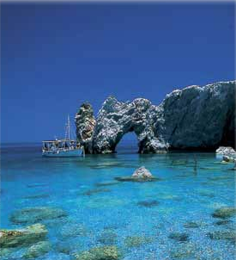

In Lefkosia, the Leventis Municipal Museum traces the development of the city from prehistoric times and gives a pretty good overview - it's not a bad place to start your Lefkosian experience. Just east of the Leventis you'll find a museum of culture, Dragoman Hadzigeorgakis. The building - a 15th-century mansion - is gorgeous. For some spectacular museum pieces try the Byzantine Museum in the downright Archbishop's Palace, which has a superb collection of religious icons and mosaics. In the grounds of the museum, St John's Cathedral has some recently restored 18th-century frescoes. Once the main entrance to the city, the Famagusta Gate, on the eastern wall, is beautifully preserved and is now used as a cultural centre.

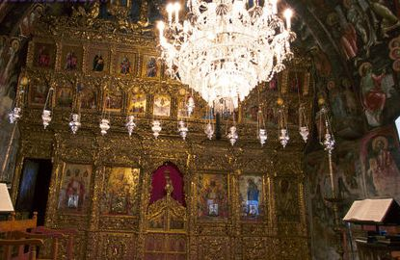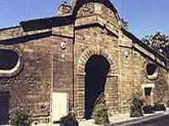

The centre of North Nicosia is Atatürk Square, in the north-west. From the square, the main street runs north to the well-preserved Kyrenia Gate. Near the gate you'll find the Turkish Museum, which lives in a 17th-century monastery and features a display of whirling-dervish memorabilia. The Selimiye Mosque, built in the 13th century, is one of the finest examples of Gothic architecture in the country. Famous around the world, the Büyük Hammam, in the south of town, is the city's largest Turkish bath.
Lying on the Mesaoria Plain, north of the Troodos Mountains, the capital city of Nicosia has a historic heart. Inside the "old city's" star-shaped 16th century Venetian walls narrow streets, walled in by one and two-storey houses of stone or plastered mud-brick, form a veritable maze. Many of these houses are gradually being restored, with wrought-iron wrapped balconies that hang over the streets and wooden shutters that shield against the sun.
The pedestrian area of Laiki Yeitonia boasts bustling shops and cafés, extending down Ledra Street to the United Nations buffer zone known as the "Green Line", which separates the largely Greek Cypriot southern Republic of Cyprus from the Turkish Cypriot area in the north.
The Central Archbishopric offers graceful architecture, the small but colourful Cathedral of Agios Ioannis, or St John (Open: Mon-Fri 08h00-12h00 and 14h00-16h00; Sat 08h00-12h00 and several museums.
Just to the west of the Venetian walls lies the Cyprus Museum, a must-see for archaeology buffs Open: Mon-Sat 09h00-17h00; Sun 10h00-13h00.

AYIA NAPA
Ayia Napa is the island's foremost site for sea, sun and fun, with a well-deserved reputation for lively nightlife. Over the last decade tourists, particularly from the UK, have adopted the town as their personal playground. The proliferation of bars and clubs reached saturation point in the last few years, and recently the locals have imposed some order on the hedonism, which means the town is a lot less chaotic now than you might think. However, this is still very much a lively resort town, and the beaches remain packed through summer while the nightlife is still energetic.
The town centre's small 16th-century monastery is a rather peaceful haven if you want to get away from it all for a while, and it reveals another side to the town - which will still be here when the tourists eventually move on.
Beach lovers and watersports enthusiasts will find much to do in this eastern corner of the island: Cape Greco in particular offers walking trails, sea caves and stunning sunsets.

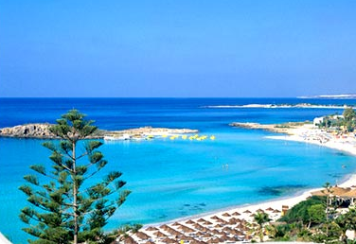

LARNACA
The whole district of Larnaca has something special to offer to the visitor, including Choirocoitia, the oldest Neolithic settlement on the island, Stavrovouni Monastery and the famous Church of Angeloktisti. Although very much a working city; the palm-lined waterfront promenade, ancient fort and historic quarter imbue Larnaca with a distinct antique flavour. Today the city is a relaxed place well loved for its easygoing attitude and friendly people. Modern Larnaca is a bustling town with its own international airport, yet it has somehow managed to retain a good deal of historic Levantine charm. Larnaca’s main tourist attraction is the nearby mosque of Hala Sultan Tekke, which draws pilgrims from across the Moslem world. The mosque is located next to a salt-lake southwest of the city and both can be visited in a day-trip. Heading out of town towards Limassol takes you into the green foothills of the Troodos Mountains, while to the west the frenetic charms of Ayia Napa await. Scuba divers are in for a treat in the shape of the Zenobia, a passenger ferry which sank in 1983 and is now rated as one of the world’s top ten wrecks.
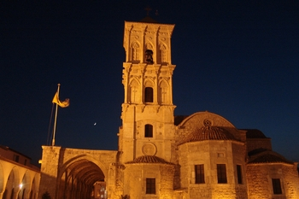 Church of Ayios Lazaros

On the east coast, a pleasant, palm-lined seafront promenade greets visitors to Larnaca's old quarter, where the main attraction is the Church of Agios Lazaros, or Saint Lazarus (Plateia Agiou Lazarou. Open: Mon-Sun 08h00-12h30 and 15h30-18h30.
The saint is believed to have lived in this area after being raised from the dead by Jesus.
Just south of the city, near the island's main international airport, is Larnaca Salt Lake. Often home to pink flamingos from December through July, on the edge of the lake is the elegant Hala Sultan Tekke Open: daily 09h00-17h00 (winter); 07h30-19h30 (summer), a memorial mosque to Prophet Mohammed's aunt.
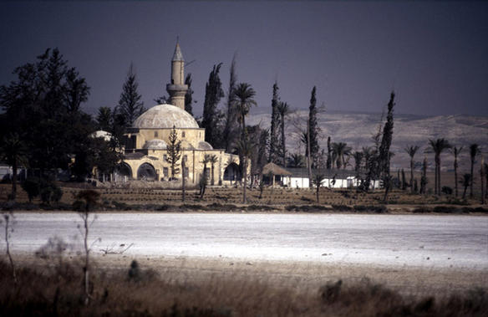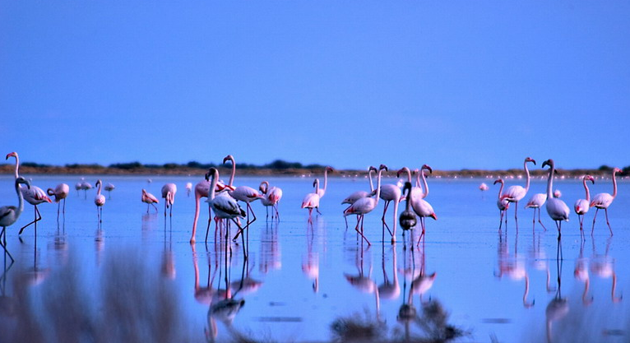

Larnaca Salt Lake

For an excellent day trip from Larnaca, try the mountain village of Lefkara (signposted off the A1, the main Nicosia-to-Limassol motorway), which is known for lace-making (lefkaritika) and its silversmiths

PAPHOS
Paphos is rapidly becoming the most important tourist centre of Cyprus. It is a small city with about 11.000 inhabitants. The old Paphos is a small village, called Ktima. Today, there is also a modern Paphos, called Kato Paphos, which is the tourist neighbourhood. This modern resort has several hotels, a boulevard with different cafés and bars and a 18 hole golf course. Paphos is a romantic city with a vibrant night-life. Close to the harbour are several archaeological sites. In former times, Nea Paphos was the most important city of the island, but earthquakes and invasions of the Saracens drove most of the people to the neighbouring hamlet of Ktima. For lovers of ancient Greece culture, Paphos is a must.
Some place to visit are : the Paphos District Museum (a collection of archeological findings),
the Georgios Eliades collection in Exo Vrysis Street (fossils and archeological objects), the Byzantine fortress of Saranda Kolones (the 40 columns), the House of Dionysus (a Roman villa from the third century that was excavated in 1962 and that has some splendid mosaics), and the House of Theseus
With plenty of luxury beachfront resorts, Paphos (on the south-west coast and home to one of the island's two international airports) makes an excellent base for touring. Look beyond the beach, and you'll also discover that this town - a UNESCO World Heritage site - embraces a wide sweep of Cyprus's history.
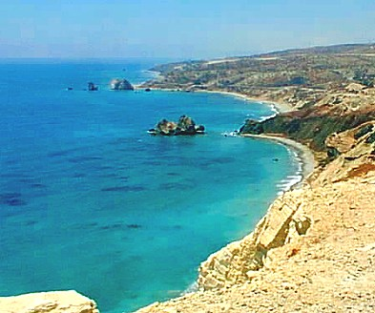

A medieval fortress (Open: daily 10h00-17h00 (18h00 in summer) stands at the harbour, where brightly painted fishing boats still moor. Nearby Roman ruins at Paphos Archaeological Park (Poseidonos Rd. Open: Mon-Sat 10h00-16h00) date mainly from the 2nd and 3rd centuries, with an Odeon (theatre), its accompanying Agora (marketplace), and the superb mosaic floors of several villas. A ten-minute drive takes you 600 years further back in time to the Tombs of the Kings (off Tafon ton Vasileon, north of harbour area. Open: daily 08h00-17h00 (winter); 08h30-19h30 (summer).
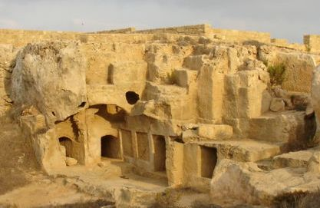

Petra tou Romiou
One look at this stunning stretch of coastline 25 kilometres east of Paphos, and it's easy to understand why, according to legend, Aphrodite chose this beach to come ashore after her birth in the sea foam off Cyprus.
Soaring cliffs and a smooth-pebbled beach frame a turquoise bay, in which the craggy rocks known as Petra tou Romiou stand guard. Parking is available off the B6 coastal road, which also offers several look-out points for admiring the views.
Approximately 15 kilometres further east, Pissouri Bay offers a beautiful beach, well equipped with showers, sunbeds and tavernas.

Kouklia (Palaepaphos)
A few kilometres inland from Petra tou Romiou stands the village of Kouklia, once home to a centre of Aphrodite worship. It was a place of pilgrimage for many of the devout, with the temple that once stood here being established as early as 1200BC.
Only the foundations of her majestic temple can be seen, but the archaeological museum next to the ruins contains many interesting finds from the site, and is itself a Lusignan manor house, parts of which date to the 13th century. Elsewhere among the scattered ruins, you can see tombs, mosaic floors and arches from various constructions over the centuries. A guidebook will point you in the right direction and is worth buying to identify the various objects uncovered by over a century of excavations.
Sanctuary of Aphrodite. 14km east of Paphos; follow signs to Kouklia off the motorway or B6 coastal road. Open: daily 09h00-16h00.

The Akamas Peninsula
The western tip of Cyprus offers a coast that is still wild - where seawater collects in rock pools, endangered sea turtles climb onto beaches to lay their eggs, and deep gorges shelter rare plants.
Lovely sea views can be enjoyed from the two nature trails that start at the Baths of Aphrodite, a small pool where the goddess reputedly bathed, beyond the village of Latchi (Latsi). Latchi has a pretty fishing harbour, and excellent watersports facilities run by local guides and tutors.
The B7 links Paphos to Polis, with a coastal road running west from Polis to Latchi and a car park near the baths.

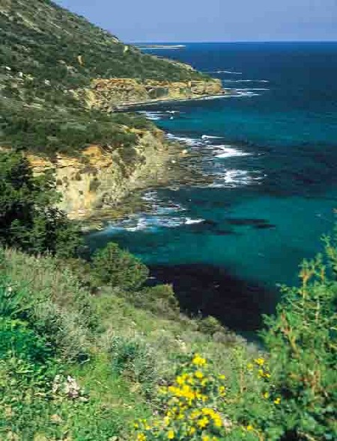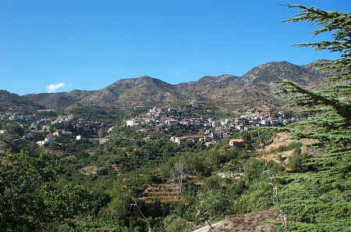

The Troodos Mountains
Rising like rumpled pillows in the centre of the island, the Troodos Mountains guarantee cool breezes even in the strong heat of July. Villages and monasteries cling, sometimes precariously, to the slopes among the scented pines, and nature trails provide excellent walking.
The once-remote locations helped protect the Byzantine "painted" churches, many of which are now UNESCO World Heritage sites: the colourful frescoes on their walls tell the stories of the Bible. In the western reaches of the Troodos Mountains, the Cedar Valley features a wildlife preserve for the moufflon, an endangered wild sheep.
LIMASSOL
This city lies on the south coast of the island, halfway between Larnaca and Paphos. Already in 2.000 BC people lived here, but it was only during the time of the crusaders that it became a flourishing city. Limassol is the second largest city of Cyprus, and certainly the liveliest one. Cypriotes sometimes call it "the Paris of Cyprus". There is always some festival or celebration going on in town. Very renowned is the Wine Festival that takes place in September. On the eastern side of the city are sandy beaches that stretch out for miles. Lovers of night-life fun will certainly not be disappointed in the many bars and discotheques in the old city.
The most important monuments are : the Limassol fortress, the Museum, the Zoo and the wine producing companies. Outside of the city is the former royal town of Amathus (now a ruin, partially submerged by water). The Kolossi Castle is a remainder of the old city state of Kourion (of which also a theater, a basilica and a stadium are preserved).
With 15 kilometres of coastline and lively events such as September's Wine Festival, the southern city of Limassol offers countless resorts and self-catering flats, and a reputation for fun.
There are also several sites of historical interest west of the city. The medieval Crusader castle of Kolossi (just off the B6 14km west of Limassol town centre. Open: daily 09h00-17h00 (19h30 in summer was once home to the production of Commandaria, the sweet wine of Cyprus.
Nearby, the Greco-Roman theatre of Kourion (B6 5km west of Kolossi.
Open: daily 08h00-17h00 (19h30 in summer). and several other remnants of ancient civilisations overlook the Mediterranean, and part of the Temple of Apollo Hylates (B6 3km west of Kourion.
Open: daily 09h00-17h00 (19h30 in summer) stands amid the ruins of its sanctuary.

SHOPPING
For centuries, women have sat outside their stone houses in the mountain village of Lefkara, stitching embroidered geometric patterns on linen: the work was so fine that - according to one story - it captivated Leonardo da Vinci, who bought an altar cloth for the cathedral in Milan. Lefkaritika, as it's called, is often referred to as lace, because of its intricate appearance: it's available throughout Cyprus, but especially in the village of Lefkara, just off the main A1 Nicosia-to-Limassol motorway.
The traditions of Cyprus handicrafts are also seen in copperware and filigree silver work, and in folk weaving and basketware. Limassol, Larnaca and Paphos offer outlets of the Cyprus Handicraft Centre, the headquarters of which is on Nicosia's Athalassa Avenue, just a block west of the A1 motorway as it enters the city outskirts. Here, you can watch weaving, lace-making and pottery making. However, villages and shops throughout the island stock similar high quality crafts.
To take home a taste of the grape harvest, try the centuries-old tradition of Commandaria, a sweet wine. For red, white and rosé wines, there's a choice of several major wine producers (Etko, Keo, Loel and Sodap), plus boutique wineries and monastery wines

INDIAN RESTAURANTS IN CYPRUS:
CITY | RESTAURANT
Paphos | Prema Indian Restaurant  Panteli Michanicou Str 9  Kato Pafos  8046 Paphos
Bombay Brassiere
Poseidonos Ave. 65
Paphos
Tel 26964083
Koh – I - noor
Kleios 7
8042 Paphos
Tel 26265544
Larnaca | Masalas Indian Restaurant  10 Ithakis Pyla  7081 Larnaca  Tel.: 24644950
Jewel Of India
39 Arch. Makariou Iii Ave
6017 Larnaca
Tel.: 24658144
Nicosia | Shalimar Indian Restaurant  15 Chiou  1086 Nicosia  Tel.: 22512240
Limassol | Mehfil Indian Restaurant  4 Nikokreontos  1101 Limassol  Tel.: 22781032

